**Exp. 1** : Design an LED CHASER

**CIRCUIT DIAGRAM:**

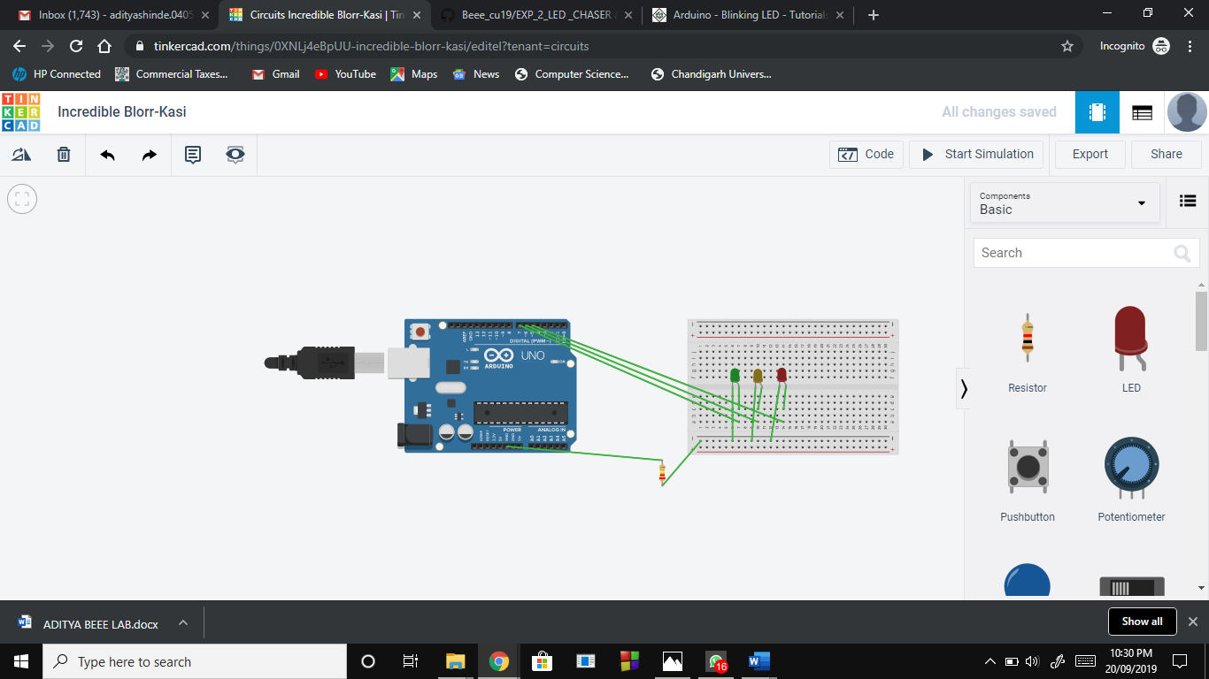

**CONCEPT USED :**

It is based on the blinking of the leds one after the other in sequence back and forth.

**LEARNING AND OBSERVATIONS:**

Led Chaser is a circuit which blinks LEDs in a particular frequency and particular pattern so that it provides the effect of illusion, LED are moving. These LED chasers are used in decorative lighting. The LEDs lights one by one for a period of 1second and the cycle repeats giving the running light appearance.

**PROBLEMS AND TROUBLESHOOTING:**

I encounter a minor issue with programming the circuit as I later on clarified.

Also It hard to make the connections, it took my efforts to made it work

**PRECAUTIONS:**

These electrical components are delicate to handle.

Also, the safety comes first when we are dealing with electric work.

Firstly, I studied the experiment and learnt about the necessary knowledge required to perform the experiment.

**LEARNING OUTCOMES:**

It was my honour to do this experiment which made me aware of working of circuits specially with the Arduino.